**MINISTERUL EDUCAŢIEI AL REPUBLICII MOLDOVA**

**UNIVERSITATEA TEHNICĂ A MOLDOVEI**

**FACULTATEA CALCULATOARE, INFORMATICǍ**

**ȘI MICROELECTRONICǍ**

**CATEDRA AUTOMATICĂ ȘI TEHNOLOGII INFORMAŢIONALE**

**Raport**

**la disciplina Tehnologii Web și Aplicații**

**Tema: JavaScript Quiz**

**Laboratorul 1**

**A efectuat: st. gr. TI-171M Lica Ion**

**A verificat: lect. sup. Poddukin Vladimir**

**Chișinău 2018**

**Task**

Create simple JavaScript quiz.

**List of Specifications**

* group files by type;
* add basic index.html file with standard elements;
* add dynamic questions with radio buttons to let user choose right answer;
* at the bottom of page add 2 buttons, first for switch to next question and second for show previous question;
* add simple CSS file for page styling;
* create .json file that contains questions and right answer;
* add score counter.

**Realization**

First off all we added an intro page to be able to start the quiz.

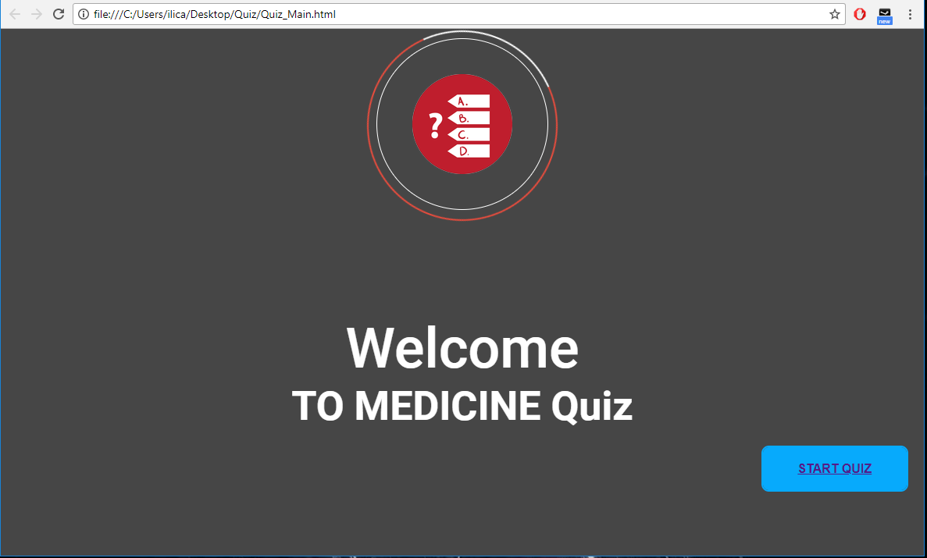

When you press the button “ Start Quiz” it will redirect to another page, where you are able to complete the quiz.

body>

<div class="bg_image">

<div class="first_circle"></div>

<div class="second_circle">

<div class="img_div">

<img src="logo.png">

</div>

</div>

<div align="center" class="txt_welcome">Welcome</div>

<div align="center" class="txt_user">TO MEDICINE Quiz</div>

<div align="right">

<button class="btn btn_start"><a href="Questions.html">Start Quiz</button>

</div>

</div>

</body>

Data is stored on server in JSON format, and we download it with Get HTTP request.

$.getJSON('https://api.myjson.com/bins/no2ah', function (data) {}; <

To show the questions we used Bootstrap to create the page with questions:

<body>

<div class="container">

<div class="row">

<div class="col-md-8 offset-md-2">

<div id="quiz" class="card" style="margin-top:100px;"></div>

<div class="card-block text-center">

<button id="previous">Previous Question</button>

<button id="next">Next Question</button>

<button id="submit">Submit Quiz</button>

</div>

</div>

</div>

</div>

<div id="results"></div>

<script src="js/app_data.js"></script>

</body>

When web page is loading, we load .json with data, for that we call function createQuiz(loadedQuestions, quiz); where we send 2 parameters json from internet and container where are shown questions.

function createQuiz(myQuestions, quiz) {

const output = [];

myQuestions.forEach((currentQuestion, questionNumber) => {

var answers = [];

for (var item in currentQuestion.answers) {}

}

We are reading data for each question and make template with question, answers and correct answer. Also in main file index.js are implemented pagination, to show questions in different pages. For that, are called function showSlide(n) where n is number of page.

function showSlide(n) {

slides[currentSlide].classList.remove("active-slide");

slides[n].classList.add("active-slide");

currentSlide = n;

if (currentSlide === 0) {

previousButton.style.display = "none";

} else {

previousButton.style.display = "inline-block";

}

if (currentSlide === slides.length - 1) {

nextButton.style.display = "none";

submitButton.style.display = "inline-block";

} else {

nextButton.style.display = "inline-block";

submitButton.style.display = "none";

}

}

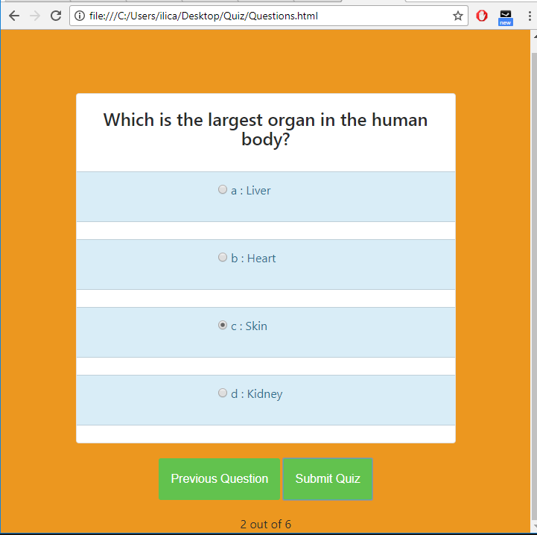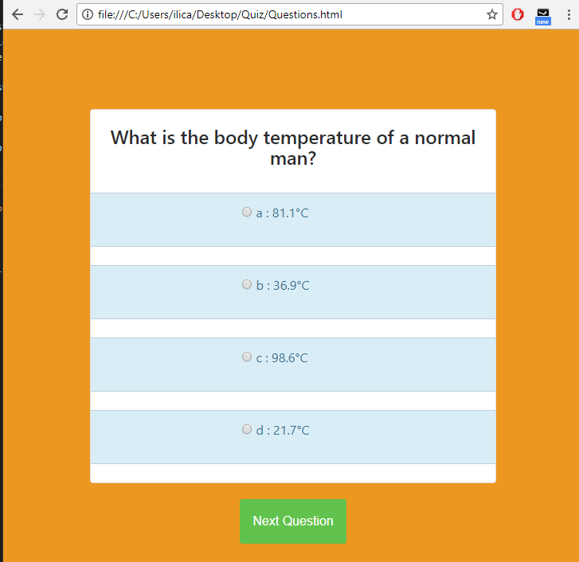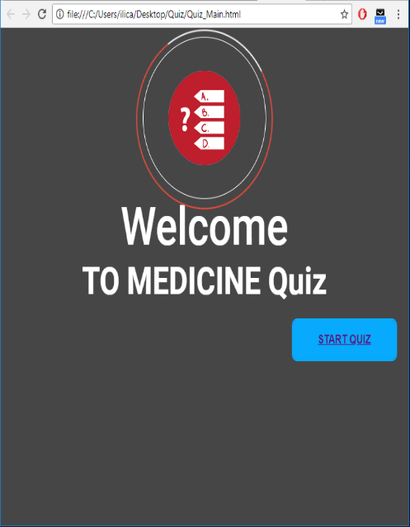**Results**

**Source Code**

Full source code can be find on <https://github.com/JohnyLica/Quiz>.

**Quiz_Main.html**

<html>

<head>

<title>Medicine Quiz</title>

<link href="css/main_Quiz.css" rel="stylesheet">

<link href="css/button.css" rel="stylesheet">

<link href='http://fonts.googleapis.com/css?family=Roboto:100,400,300,500,700' rel='stylesheet' type='text/css'>

<script src="js/question.js"></script>

<script src="js/button.js"></script>

</head>

<body>

<div class="bg_image">

<div class="first_circle"></div>

<div class="second_circle">

<div class="img_div">

<img src="logo.png">

</div>

</div>

<div align="center" class="txt_welcome">Welcome</div>

<div align="center" class="txt_user">TO MEDICINE Quiz</div>

<div align="right">

<button class="btn btn_start"><a href="Questions.html">Start Quiz</button>

</div>

</div>

</body>

</html>

**Questions.html**

<html>

<head>

<title>Quiz</title>

<link rel="stylesheet" href="css/questions.css">

<script src="http://code.jquery.com/jquery-3.3.1.min.js"></script>

<link rel="stylesheet" href="https://maxcdn.bootstrapcdn.com/bootstrap/4.0.0-alpha.6/css/bootstrap.min.css">

</head>

<body>

    <div class="container">

        <div class="row">

            <div class="col-md-8 offset-md-2">

                <div id="quiz" class="card" style="margin-top:100px;"></div>

               <div class="card-block text-center">

                        <button id="previous">Previous Question</button>

                        <button id="next">Next Question</button>

                        <button id="submit">Submit Quiz</button>

                </div>

            </div>

        </div>

    </div>

    <div id="results"></div>

   <script src="js/app_data.js"></script>

</body>

</html>

**app_data.js**

var questions = [];

$.getJSON('https://api.myjson.com/bins/no2ah', function (data) {

questions = data;

function createQuiz(loadedQuestions, quiz) {

const output = [];

loadedQuestions.forEach((currentQuestion, questionNumber) => {

var answers = [];

for (var item in currentQuestion.answers) {

answers.push(

`<li class="list-group-item list-group-item-info">

<div class="form-check">

<label class="form-check-label">

<input align="center" type="radio" name="question${questionNumber}" value="${item}">

${item} : ${currentQuestion.answers[item]}

</label>

</div>

</li> <br>`

);

}

output.push(

`<div class="slide">

<div class="card-block">

<h4 class="card-title">${currentQuestion.question}</h4>

</div>

<ul class="list-group list-group-flush answers">${answers.join("")}</ul>

</div>`

);

});

quiz.innerHTML = output.join("");

}

function showResults() {

const answerContainers = quiz.querySelectorAll(".answers");

let numCorrect = 0;

questions.forEach((currentQuestion, questionNumber) => {

const answerContainer = answerContainers[questionNumber];

const selector = `input[name=question${questionNumber}]:checked`;

const userAnswer = (answerContainer.querySelector(selector) || {}).value;

if (userAnswer === currentQuestion.correctAnswer) {

numCorrect++;

answerContainers[questionNumber].style.color = "lightgreen";

} else {

answerContainers[questionNumber].style.color = "red";

}

});

resultsContainer.innerHTML = `${numCorrect} out of ${questions.length}`;

}

function showSlide(n) {

slides[currentSlide].classList.remove("active-slide");

slides[n].classList.add("active-slide");

currentSlide = n;

if (currentSlide === 0) {

previousBtn.style.display = "none";

} else {

previousBtn.style.display = "inline-block";

}

if (currentSlide === slides.length - 1) {

nextBtn.style.display = "none";

submitBtn.style.display = "inline-block";

} else {

nextBtn.style.display = "inline-block";

submitBtn.style.display = "none";

}

}

function showNextSlide() {

showSlide(currentSlide + 1);

}

function showPreviousSlide() {

showSlide(currentSlide - 1);

}

var currentSlide = 0;

const previousBtn = document.getElementById("previous");

const nextBtn = document.getElementById("next");

const submitBtn = document.getElementById("submit");

const quiz = document.getElementById("quiz");

const resultsContainer = document.getElementById("results");

createQuiz(questions, quiz);

const slides = document.querySelectorAll(".slide");

showSlide(0);

submitBtn.addEventListener("click", showResults);

previousBtn.addEventListener("click", showPreviousSlide);

nextBtn.addEventListener("click", showNextSlide);

});

**Conclusion**

Doing this small quiz, we learned how to use JavaScript as a client side programming language. You will find JavaScript not only on every website but also on mobile sites, games and web applications. JavaScript is Client-side Processing. This means the code is executed on the user’s processor instead of the web server, thus saving bandwidth and reducing extra load of the server. JavaScript is mostly used to interact with HTML objects, it can also be made to interact with other non-HTML objects such as browser plugins, CSS properties, the current date, or the browser itself. To write JavaScript code, all you need is a basic text editor like Notepad or Visual Studio Code.